THE KINDNESS ROCKS PROJECT
https://www.thekindnessrocksproject.com/

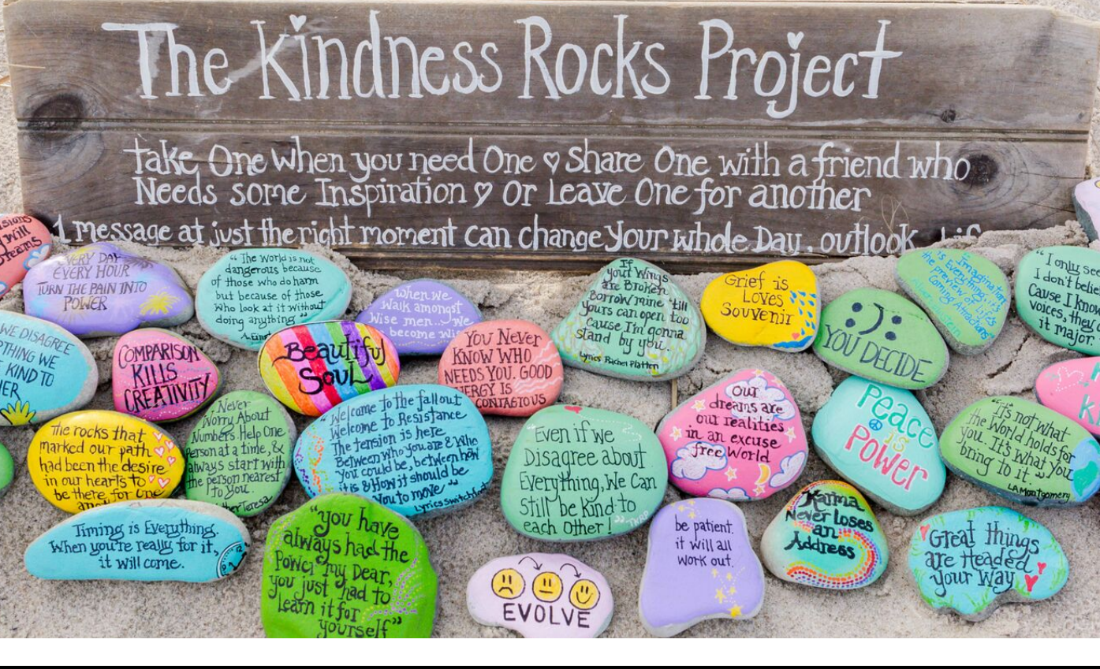

STEP #1 YOU WILL NEED SOME ROCKS (Flat smooth river rocks) Check your local craft store, garden center, or Amazon. The 1.5″ to 3″ size works best!

STEP #2 PAINT THE ROCKS- (use NON-TOXIC PAINT)
This will prepare the rock surface for your artwork/writing and seal the rock so your paint pens will last longer. List of supplies below.

STEP #3 PAINT PENS TO CREATE YOUR ARTWORK
BE SURE TO ADD…#THEKINDNESSROCKSPROJECT to the back of each rock you drop so others can join. DO NOT ADD STICKERS OR GOOGLE EYES TO YOUR ROCKS AS THEY CAN HARM ANIMALS

STEP #4 TOPCOAT YOUR ART W/ NON-TOXIC CLEAR SEALANT
This will protect the artwork from the elements. You can also coat with Duraclear brush on sealant or Krylon clear acrylic spray. This will typically dry in 10 minutes or less.

WHERE DO I FIND INTERESTING, INSPIRING QUOTES TO USE?
You can search Pinterest, Instagram or Brainy Quote, or create your own sentiments that come straight from your heart!
Some Quotes:
This was dropped to let you know that You matter!
Hey, Psst… just wanted to let you know how awesome you are
Supplies:
Rocks
Paint Brushes
Acrylic Black Thin Tip Paint Pen
*When sharing your rocks, be sure to acquire permission.

